title of the paper (12 pt, bold)

Presenting Author’s Name¹, Author’s Name² (11 pt, bold)
¹University, Faculty, Department/Laboratory, Address, City, Country (10 pt, italic)
²Company, Address, City, Country (10 pt, italic)
E-mail of the Presenting Author

An extended abstract must be prepared for oral and poster presentations. Please use this template in order to shape your text correctly. It is the author’s responsibility to submit an appropriate abstract (spelling, grammar, scientific facts, accuracy and layouts).

The title of the paper must be written at maximum length of two lines. The name of the authors must be written in bold, with font size 11 pt. The name(s) of the presenting author(s) must be underlined. The name(s) of the institution must be in italic, with font size 10 points. Add an e-mail contact and information of the presenting author. Leave two blank lines with font size 11 pt. before the body text. The body text must be written with font size 11 pt.

Abstract structure and style
The content of the abstract must include an Introduction with the research problem, a short literature review and the aim of the research, an Experimental part with a short description of materials, procedures and analytical methods, main Results, a Discussion, Conclusion, Keywords.

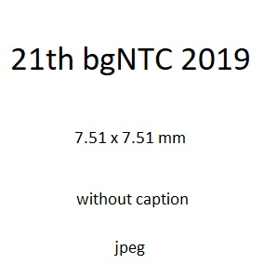
Each abstract will be reviewed by the Scientific Committee and selected for the next publication in the Textile & Garment Journal, ISSN 1310-912X in the context of conference topics.

You are kindly asked to write your text in MS Word format directly into this document template, since all styles are already prepared.

The abstract should be written in English language. Please use Arial font and a single line spacing for the entire abstract. There must be a top margin of 2.5 cm and a bottom, left and right margins of 2.5 cm. The length of the abstract should be almost one page (90-100%) with a total length of 800–1000 words, including not more than one Figure at 7.5 x 7.5 cm, without caption.

Keywords: the keywords must include 4–5 words. After the keywords, leave two blank lines before the reference list.

All abstracts must be submitted to the organizing committee not later than August 31st 2019, and they will be published in the Textile & Garment Magazine, ISSN 1310-912X (print),
ISSN 2603-302X (Online), issue 10/2019.

PS Dear colleagues please do not delay to present your requests to participate in the conference. Specifying the average number of participants until august 31st will optimize the organization of scientific sessions.

